Batch: 4
Roll No.: 16010123012

Experiment / Assignment / Tutorial No.: 08

TITLE: To visualize multiple variables simultaneously

Objective: To implement and evaluate different visualization techniques for analyzing high-dimensional datasets _________________________________________________________________________
Expected OUTCOME of Experiment: CO 3
Apply data visualization best practices
_____________________________________________________________________
Books/ Journals/ Websites referred:
- Data Analysis with Microsoft Excel, Wayne L. Winston, Microsoft Press.
- Excel 2019 Bible, John Walkenbach, Wiley.
- Practical Statistics for Data Scientists, Peter Bruce and Andrew Bruce, O’Reilly Media
_____________________________________________________________________
Background Theory:
Multivariate data consists of observations with three or more variables. Standard 2D plots are often insufficient for understanding the full structure of such data. This experiment utilizes three categories of visualization:
Correlation Analysis (SPLOM/Heatmap): Breaks down the dataset into pairwise 2D comparisons to find linear relationships.
Profile Analysis (Parallel Coordinates): Plots all dimensions simultaneously on parallel axes to view the "profile" of each data point.
Projection (PCA): Mathematically compresses multiple variables into principal components to visualize clusters in 2D space.
Laboratory Work:
Tools & Dataset
- Programming Language: Python 3.x
- Libraries: Pandas, Matplotlib, Seaborn, Scikit-Learn
- Dataset: Palmer Penguins (Contains 4 numeric variables: Bill Length, Bill Depth, Flipper Length, Body Mass; and 1 categorical variable: Species).

Step 1: Data Preparation
Import the necessary libraries (seaborn, matplotlib, pandas, sklearn).
Load the penguin’s dataset.
Clean the data by dropping rows with missing values (NaN) to ensure accurate plotting.

Step 2: Pairwise Relationship Analysis
Generate a Scatter Plot Matrix (SPLOM): Plot every numeric variable against every other variable. Use color (hue) to distinguish between species.
Generate a Correlation Heatmap: Calculate the correlation matrix (Pearson coefficient) and visualize it using a color-coded heatmap.
Step 3: Multi-Variable Interaction
Generate a Bubble Chart: Create a scatter plot of Bill Length vs. Bill Depth.
Map Body Mass to the size of the bubbles and Species to the color. This visualizes four variables at once.
Step 4: High-Dimensional Profiling
Generate a Parallel Coordinates Plot: Standardize the data (optional but recommended) or plot raw values if scales are similar.
Draw lines connecting the values of each feature for every penguin instance. Color lines by species.
Step 5: Dimensionality Reduction
Standardize the features (scale to mean=0, variance=1).
Apply Principal Component Analysis (PCA) to reduce the 4 numeric dimensions into 2 Principal Components.
Plot the two new components on a scatter plot.
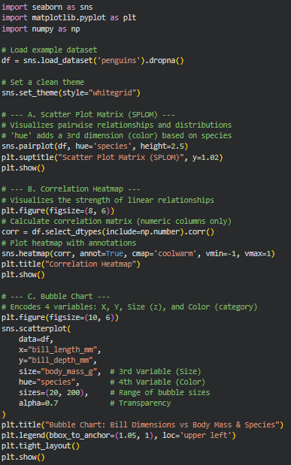
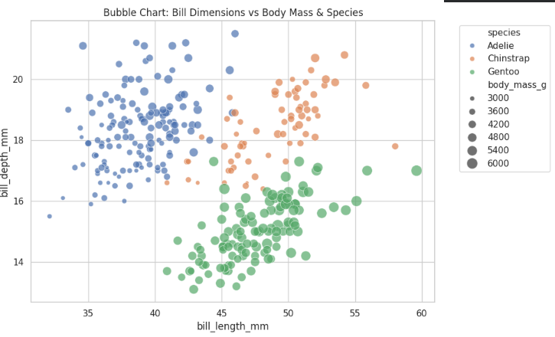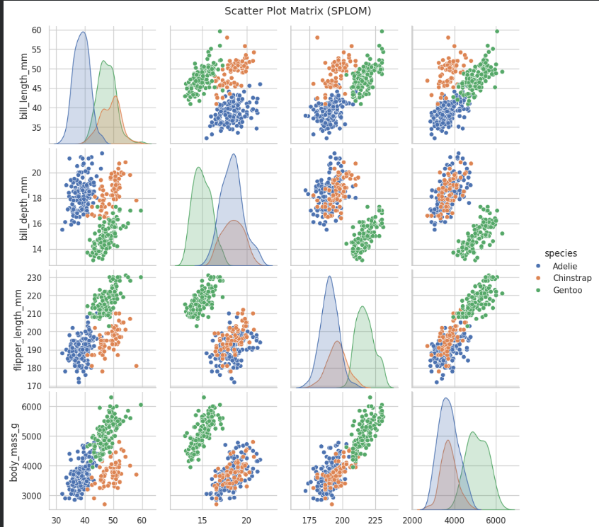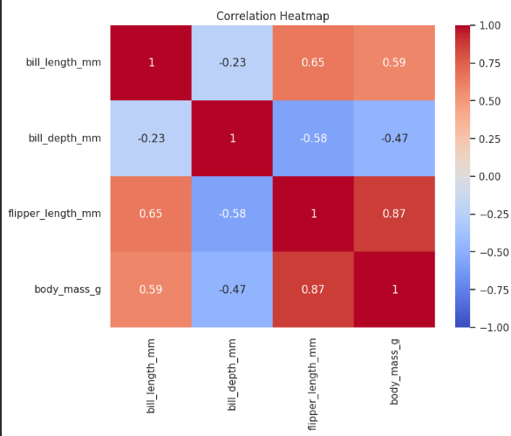
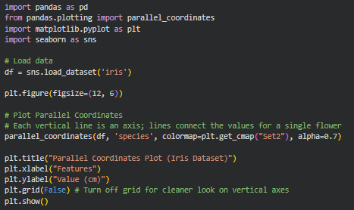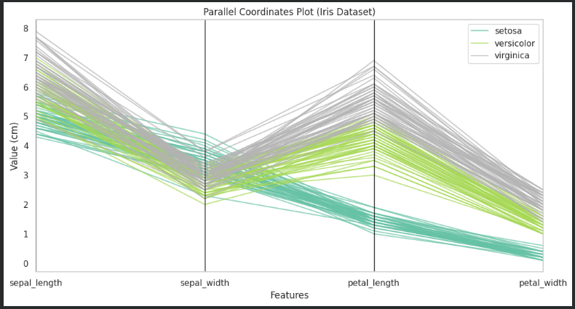
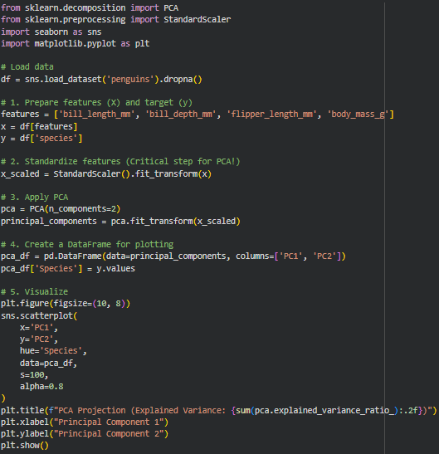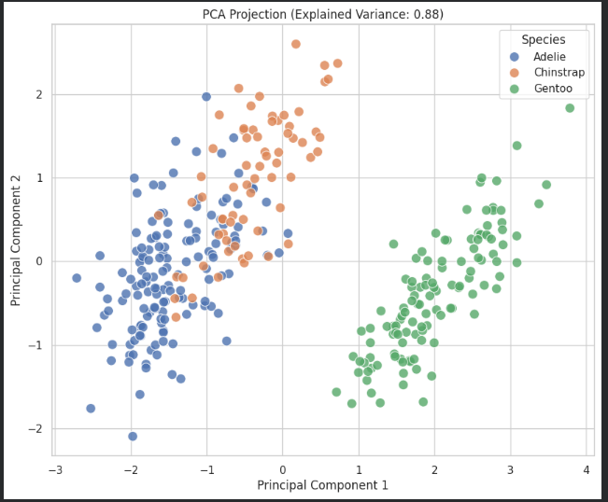

Conclusion
In this experiment, multivariate data visualization techniques were implemented using Python to analyze high-dimensional datasets effectively. Various methods such as scatter plot matrix, correlation heatmap, bubble chart, parallel coordinates plot, and Principal Component Analysis (PCA) were used to explore relationships among multiple variables. These visualizations helped in identifying correlations, patterns, clusters, and differences among penguin species.
Post Laboratory Questions:
Write in brief about multi variate visualization techniques which are not covered in above write up.
Apart from the techniques used in this experiment, several other multivariate visualization methods are available. Radar charts represent multiple variables on a circular axis and are useful for comparing profiles. 3D scatter plots allow visualization of three variables simultaneously but may be difficult to interpret due to perspective issues. Heatmaps with clustering (clustered heatmaps) group similar variables and observations to reveal hidden patterns. Andrews curves transform multivariate data into continuous curves, enabling pattern recognition. Glyph-based visualizations such as star plots and Chernoff faces represent multiple variables using shapes or facial features. These techniques provide alternative ways to analyze complex datasets depending on the nature of the data and the analysis requirements.

